

NAME OF THE PROJECT

Car Price Prediction

Submitted by:

Chandan Kumar

**ACKNOWLEDGMENT:**

This includes mentioning of all the references, research papers, data sources, professionals and other resources that helped me and guided me in completion project.

**INTRODUCTION**

**Problem statement**

The main aim of this project is to predict the price of used car. we have seen lot of changes in the car market. Now some cars are in demand hence making them costly and some are not in demand hence cheaper. One of our clients works with small traders, who sell used cars. They are looking for new machine learning models from new data. We have to make car price valuation model.

This dataset contains information about used cars. The columns in the given dataset are as follows:

**Car_Name**

**Year**

**Selling_Price**

**Present_Price**

**Kms_Driven**

**Fuel_Type**

**Seller_Type**

**Transmission**

**Owner**

The data consists of records of roughly 301 cars and 9 features.

All the Lifecycle in A Data Science Project is divided into Six parts:

1. Data Cleaning

2. Exploratory Data Analysis

3. Data Pre-processing

4. Model Building

5. Model Evaluation

6. Selecting the best mode

[**Exploratory Data Analysis**](https://medium.com/p/d25559cf2d2a/edit#f327)

Now, let’s start with the task of machine learning to predict car prices using Regression. I will start by importing all the necessary libraries that we need for this task and import the dataset.

**Importing libraries**

**Importing the dataset**

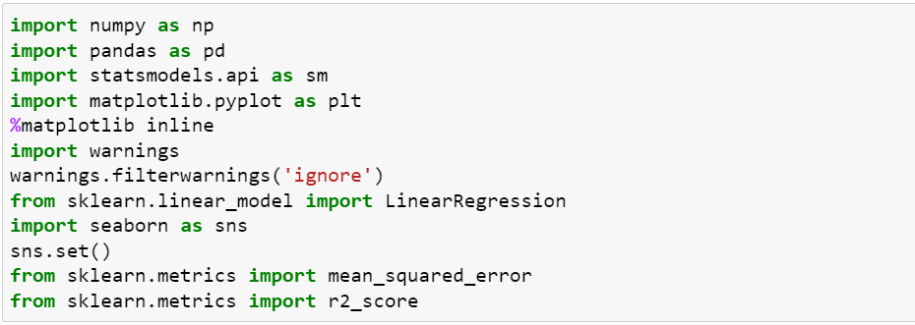



The first thing that we can do when tackling a data science problem is getting an understanding of the dataset that you are working with. Key observations and trends in the data were noted down. All correlations within the variables and the output ‘*selling_price*’ were monitored.

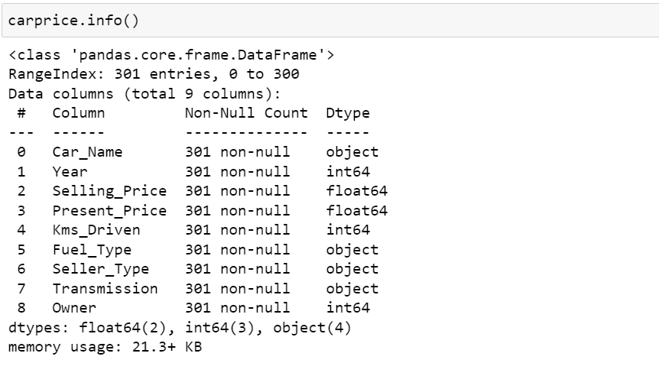

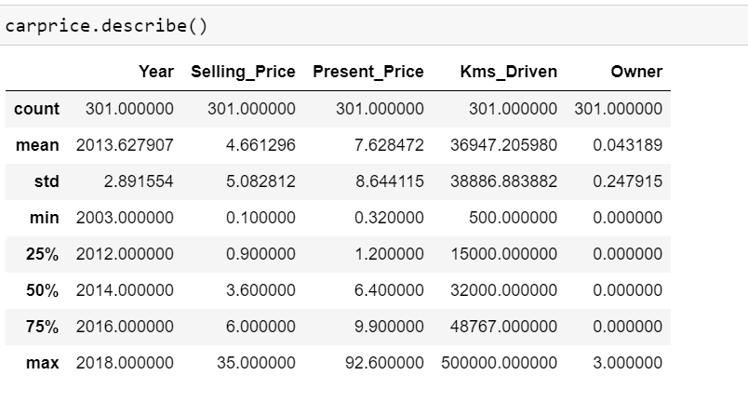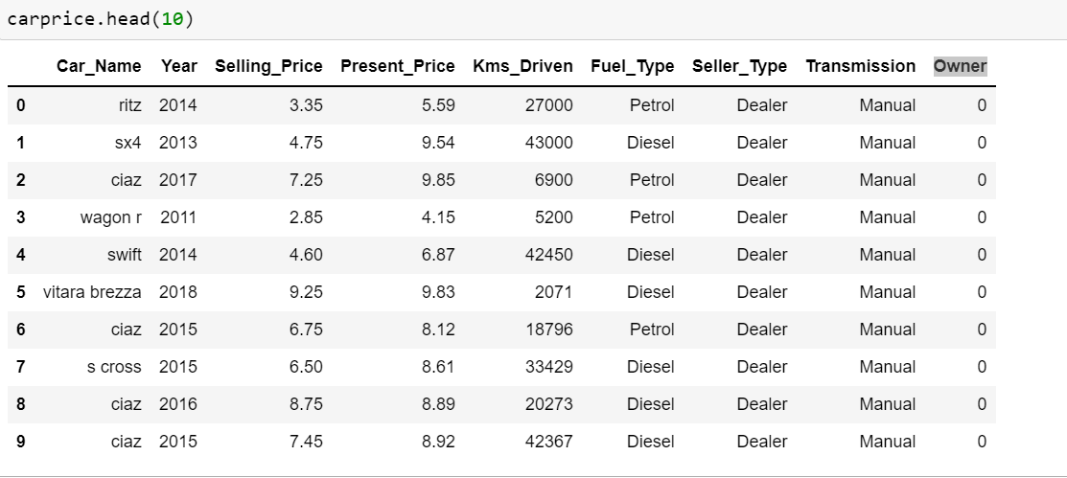

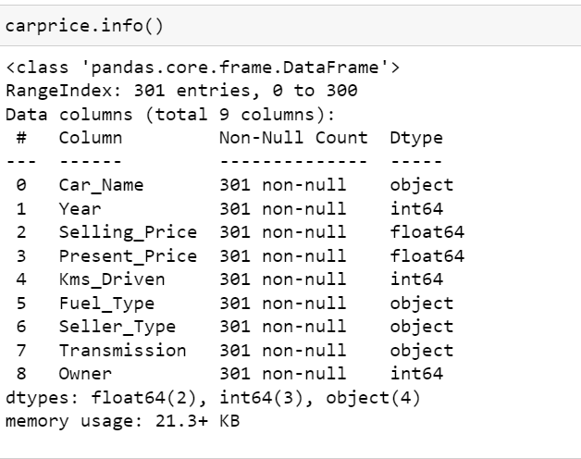

You can also use **distplot ()** to fit a parametric distribution to a dataset and visually evaluate how closely it corresponds to the observed data.

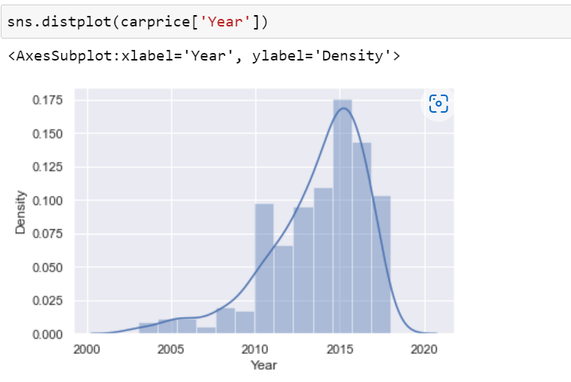

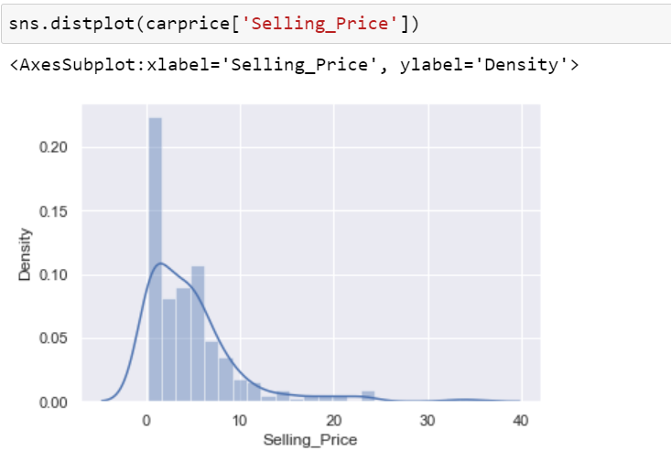

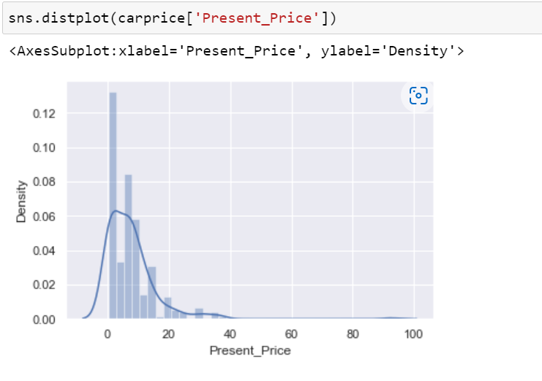

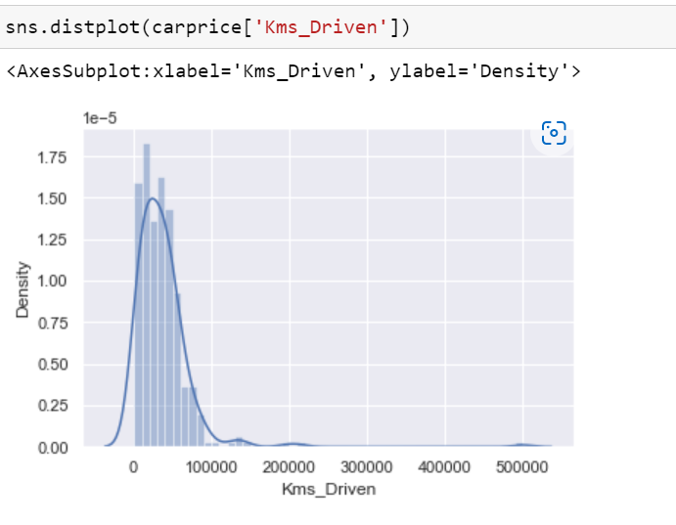

Scatter plots & Bar plot are used to observe relationships between variables and uses dots to represent the relationship between them. here points are nearly aligned in a line.

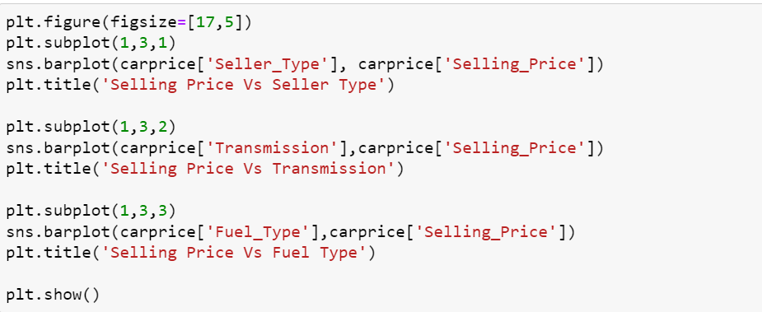

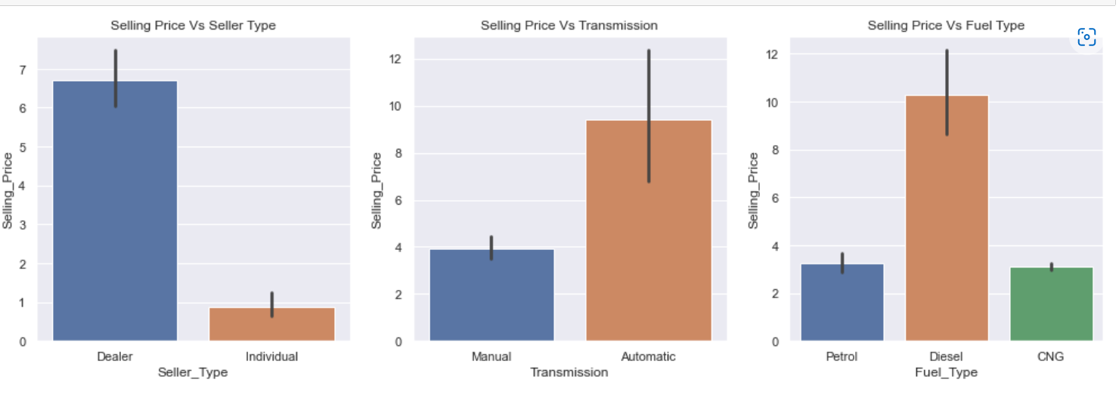

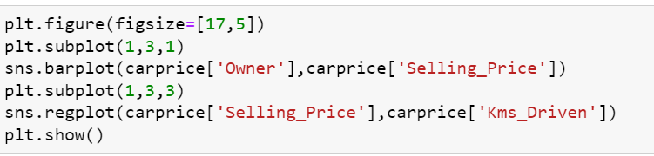

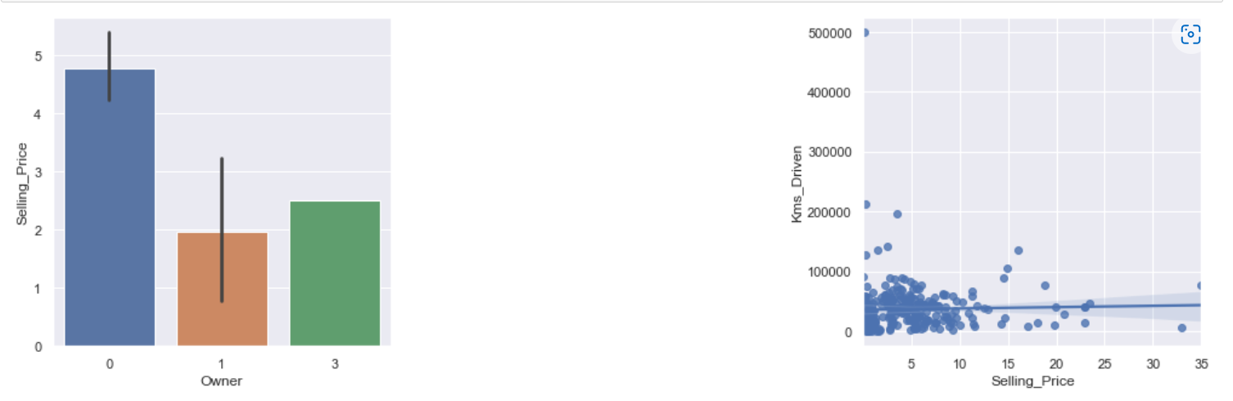

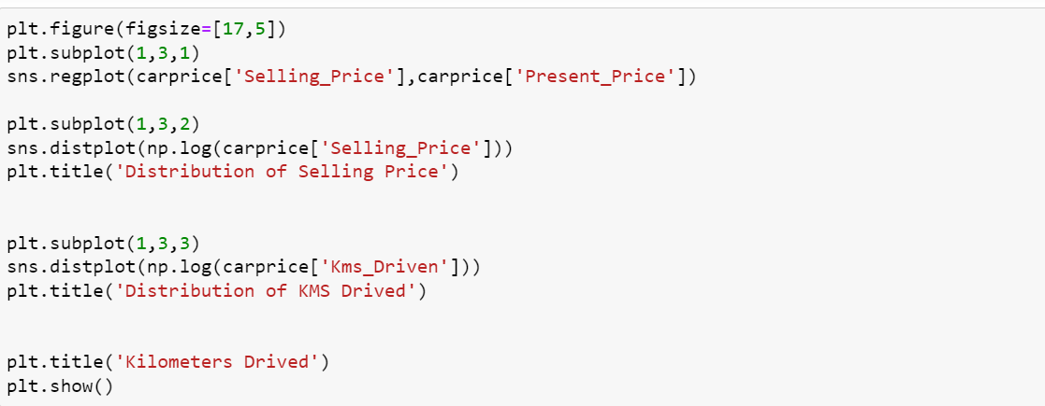

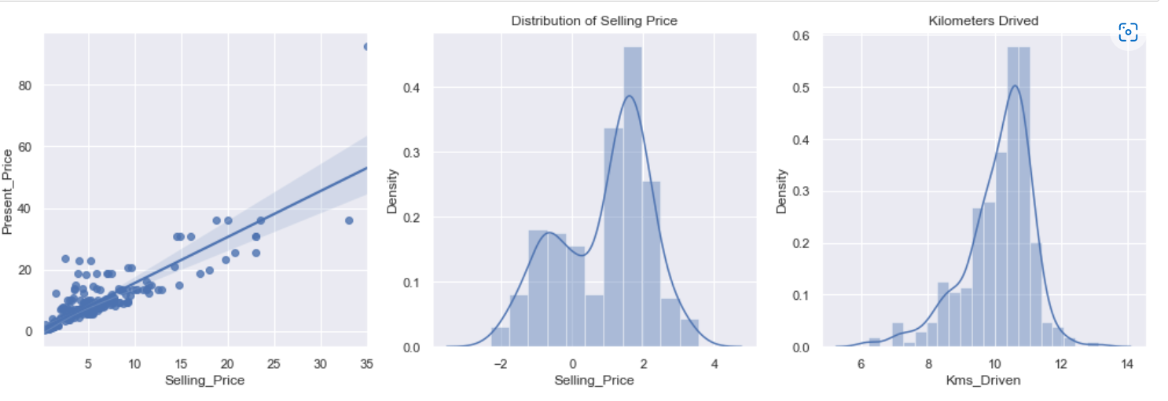

User to heat map.

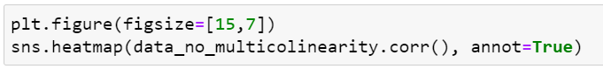

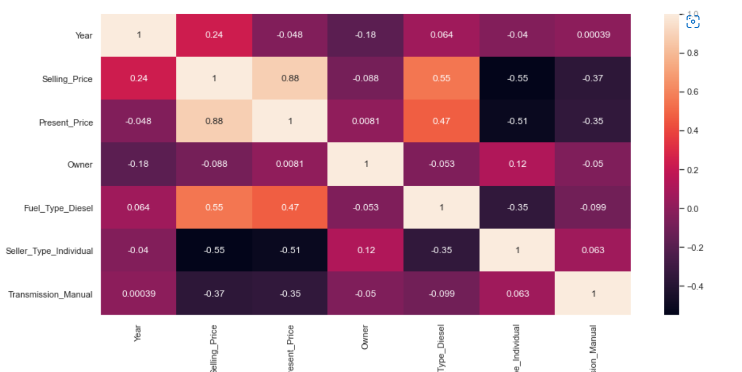

Create a multiple Model.

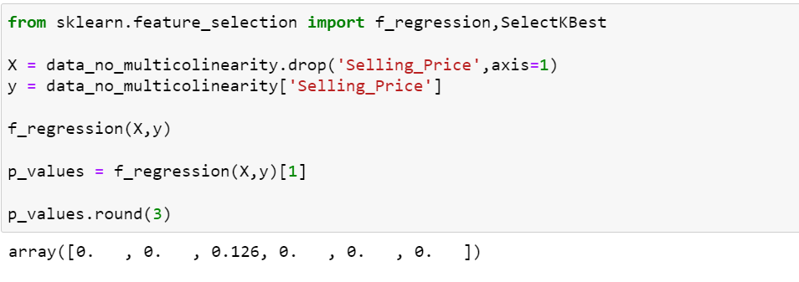

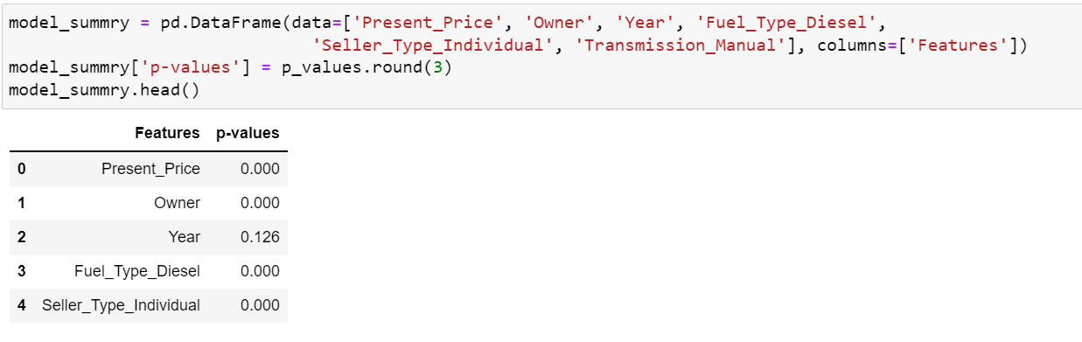

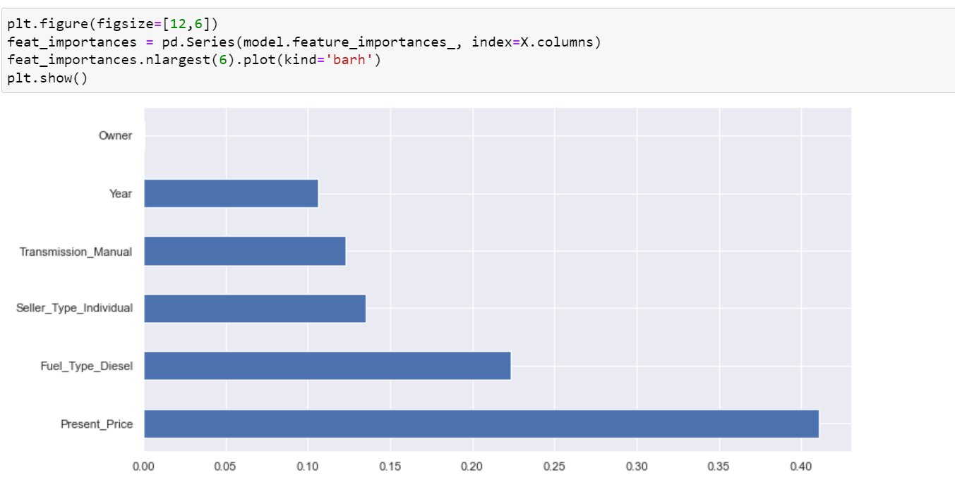

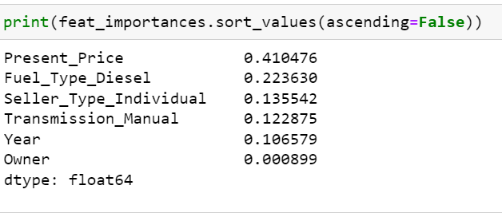

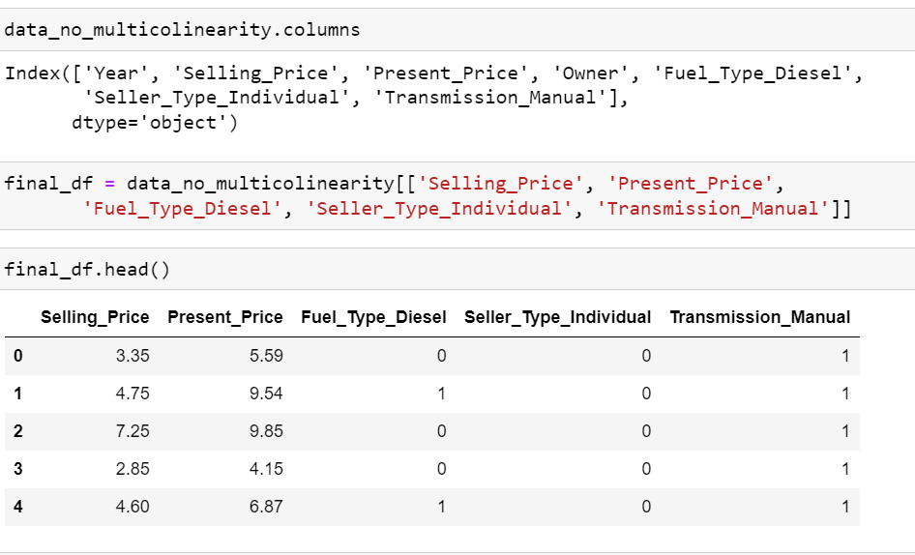

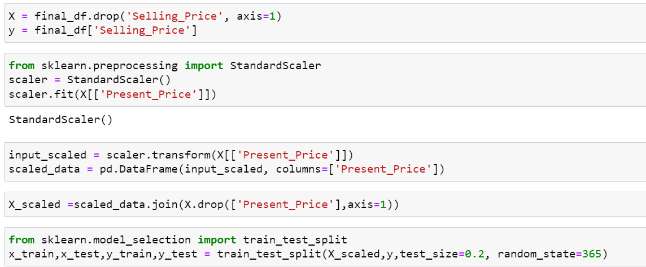

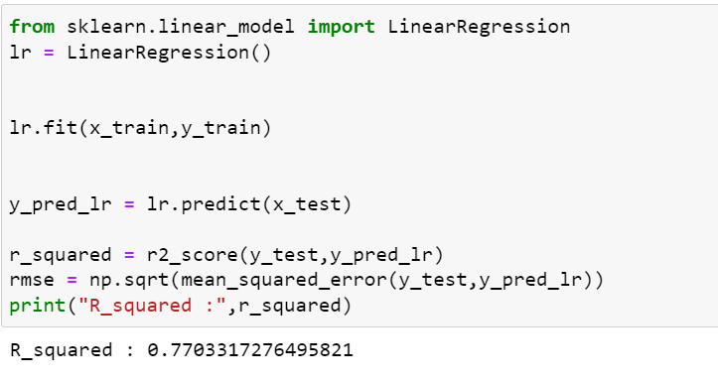

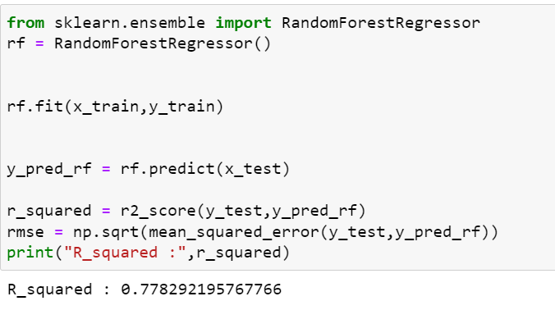

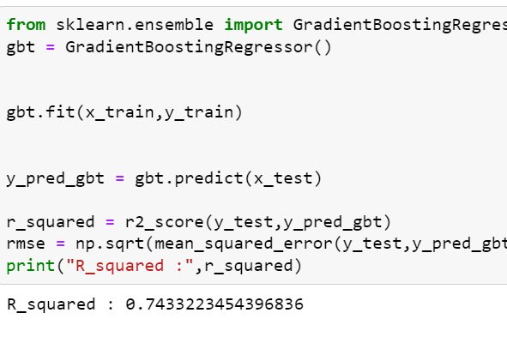

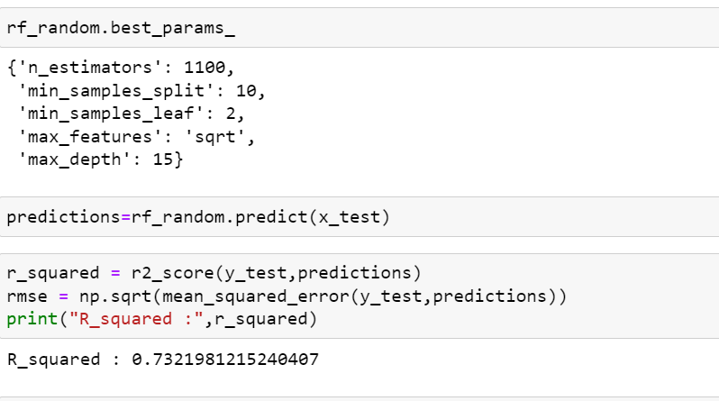

Conclusions:

Present price of a car plays an important role in predicting Selling Price, One increases the other gradually increases.

Selling Price of cars with Fuel Type Diesel is higher.

Car of Manual type is of less priced whereas of Automatic type is high.

Cars sold by Individual tend to get less Selling Price when sold by Dealers.